## Objective

The objective of this document is to explain step by step procedure on how to integrate iTKO – Lisa tests with Team City.

## Step 1:- Install Java JDK

Install Java JDK from [here](http://www.oracle.com/technetwork/java/javase/downloads/jdk7u7-downloads-1836413.html) . Select the appropriate version 32 bit /64 bit from the download list.

Once the installation is completed, ensure that the JDK bin folder is created under program files.

Note: - Installing JRE alone would not be sufficient as the ANT libraries use the JDK bin folder.

Java Version tried: - jdk1.7.0_07

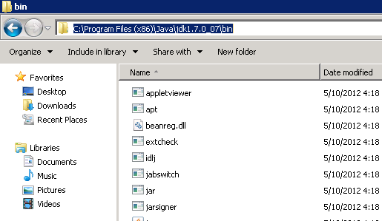

## Step 2:- Install Apache ANT Libraries

Install the Apache ANT libraries from <http://ant.apache.org/bindownload.cgi>

Unzip the binary file to C:\ as shown below.

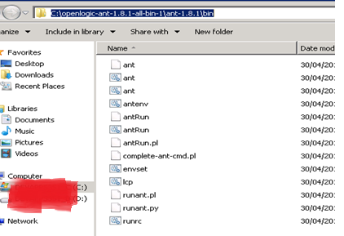

## Step 3: - Install Junit libraries

Install the Junit binaries from <http://www.junit.org/>

Version of Junit doesn’t matter as long as you have the Junit jar files.

Once you unzip the Junit zip file, copy the 3 jar files shown below to the Ant\lib folder

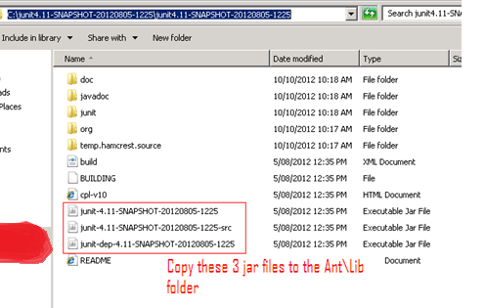

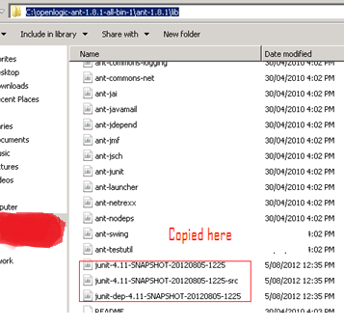

## Step 4:- Set the environment variables

Set the env variable for Java, Ant and path as below.

**ANT_HOME** - Your Ant directory

**JAVA_HOME** – Your jdk directory

**LISA_HOME** – Your Lisa directory

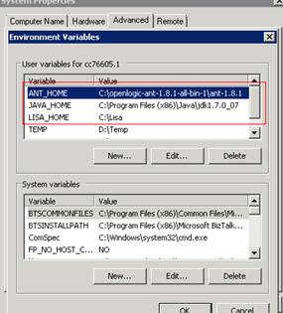

Once these 3 environment variables are set, set the path variable as below.

Add the java Bin folder and the ant bin folders in the Path variable separated by ‘;’

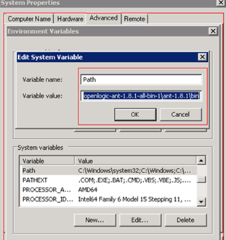

To verify the set up do the following

Open a command prompt and type

%ANT_HOME% - this should display your Ant path.

%JAVA_HOME% - this should display Jdk path

Simply type ant at the command prompt, ant should display a message as below.

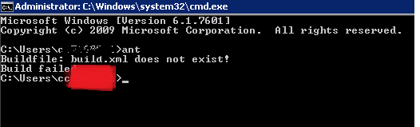

## Step 5: - Running the Lisa test using ant build.xml

By default when you install Lisa, there would be a build.xml file under “Lisa\examples”.

This build script can be used to run the Lisa tests. Copy the build script to the projects folder inside Lisa and make changes to the xml as show below.

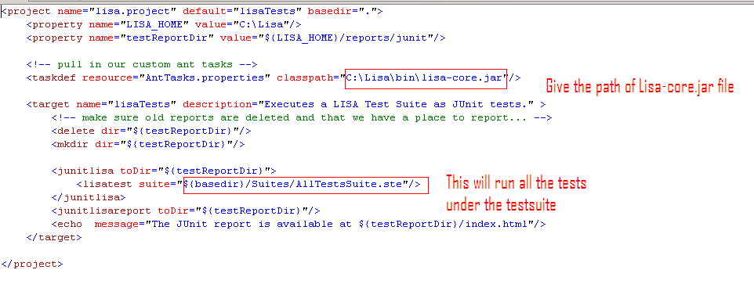

Launch a command prompt and navigate to the Lisa projects folder and run the below command to run the Lisa tests.

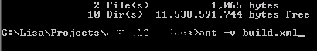

The build should be successful and the Lisa tests should run at this stage from command prompt.

Ant –v switch specifies the build to run in verbose mode, which logs everything in the trace.

## Step 6:- Integrating Ant with Team city.

Create a new project in Team city with runner type as Ant and set the attributes as show below.

Once the settings are done, save the project. And we are all set to run the Lisa test from Team city.

Click ‘Run’ to trigger your first Team City Lisa build.

